1. Create git repository on git.epam.com/github.com and clone using SSH keys. 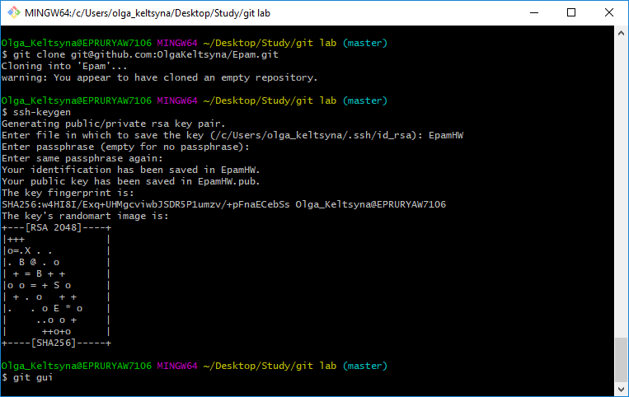

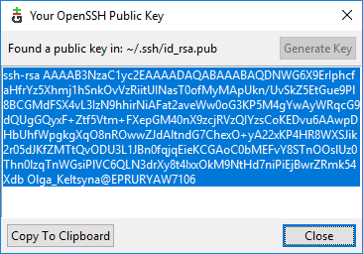

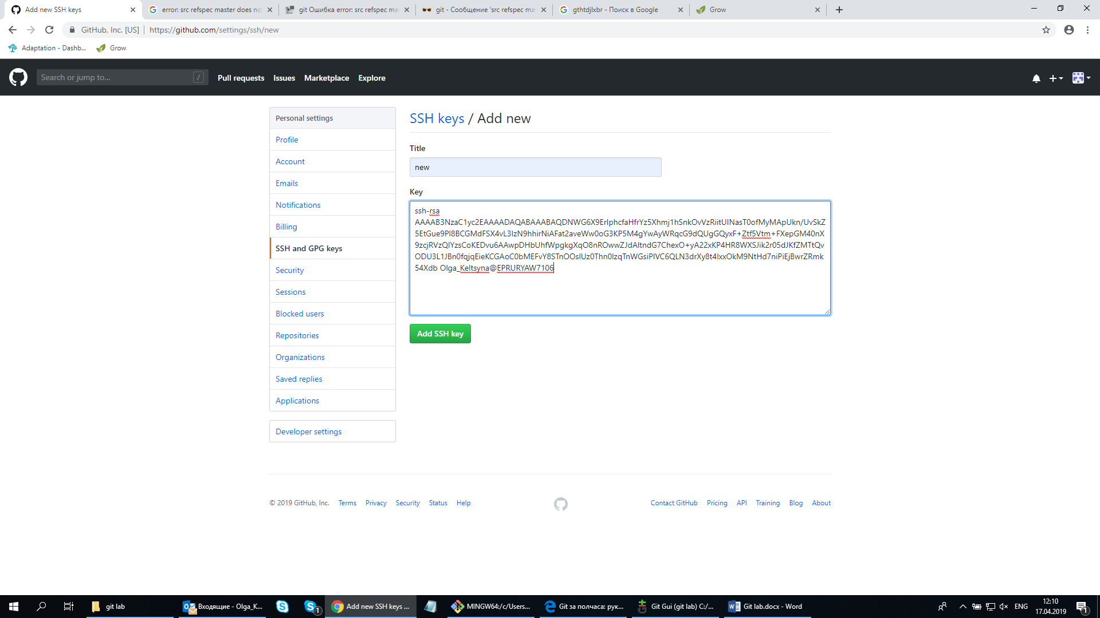

2. Сreate a text file "Hello", push on github your chandes. Delete this file from the local repository. Create 3 commits in master branch.(1point)

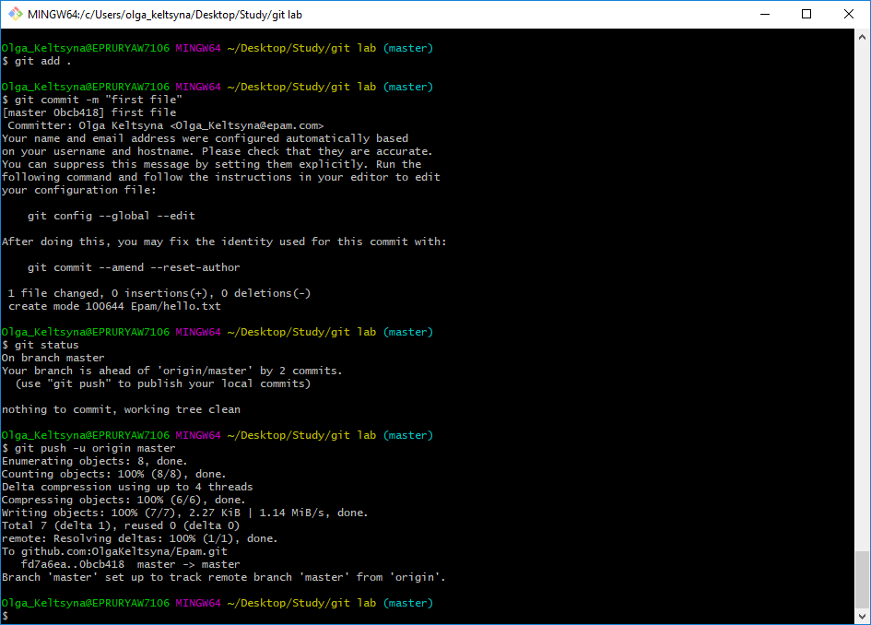

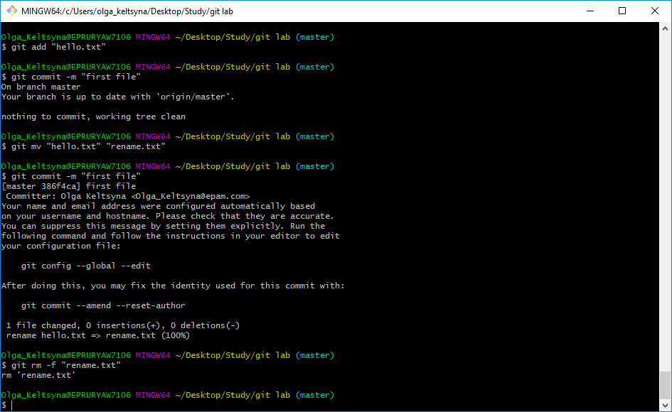

3. Create new "dev" branch and push 1 commits inside.

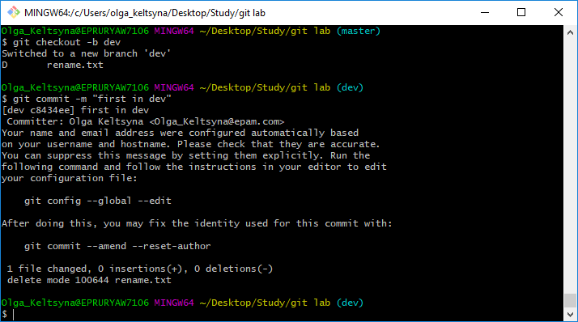

Switch to master and create new "cherry-pick" branch and push 2 commits inside. Create new "dev2" branch. (2point)

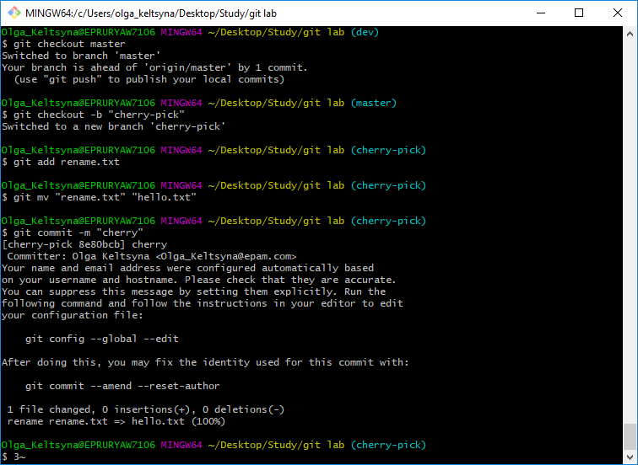

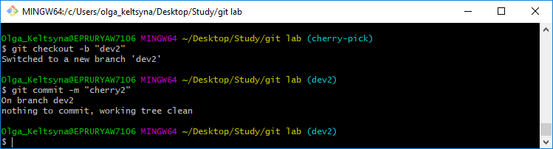

4. Push 1 commit inside dev branch which will produce a conflict with previous commit to master branch. (1point)

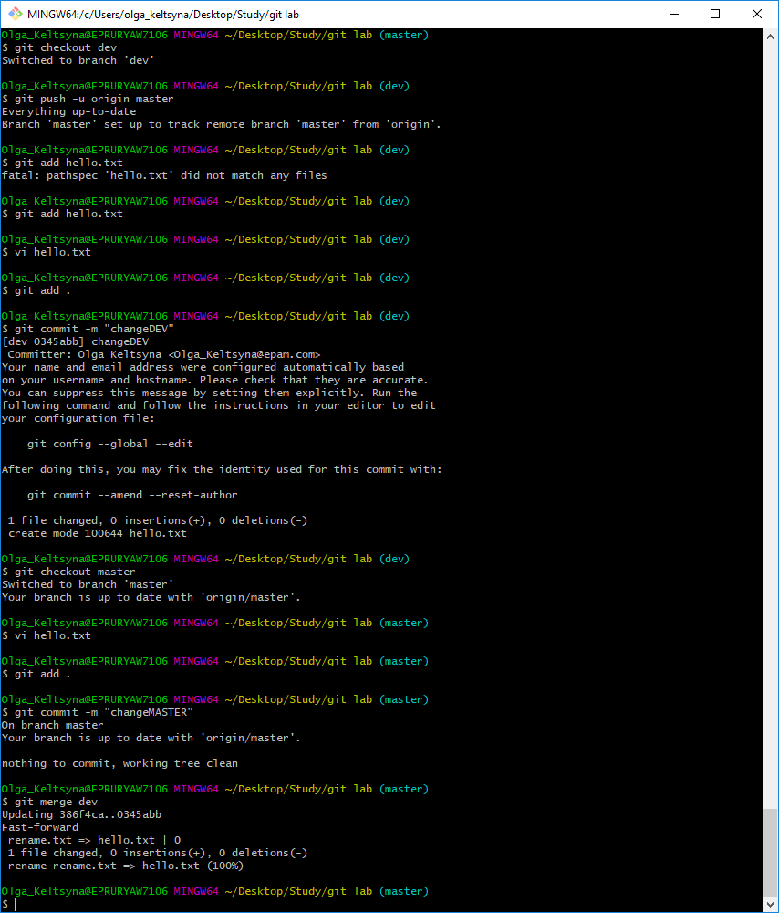

5. Merge "dev" to "master" : resolve conflict and save history of commits for "dev" branch. (2point)



6. Add 2 additional commits to "dev", 1 commit in master. Rebase "dev" with new commits from "master". (1point)

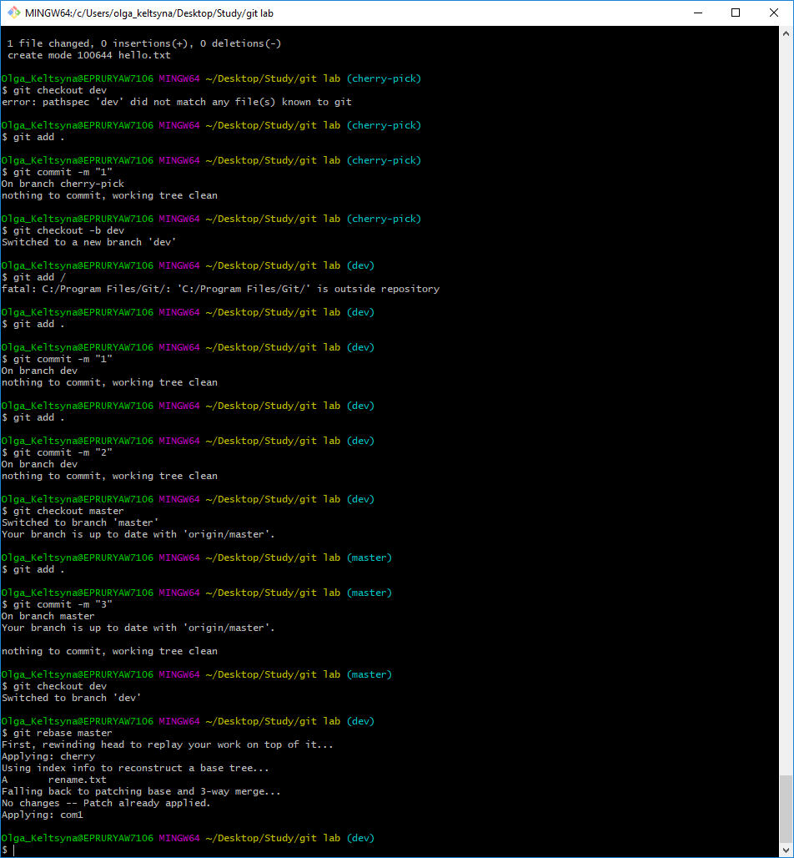

7. Remove all the branches except "master" + "cherry-pick". (1point)

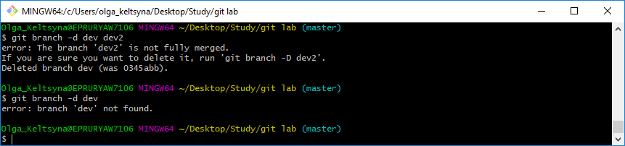

Исправила:

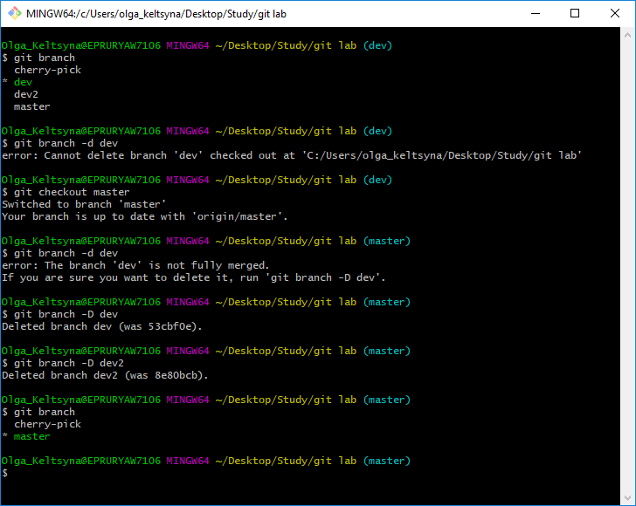

8. Delete a text file "Hello" (in 2 point) from the remote repository too. (1point)

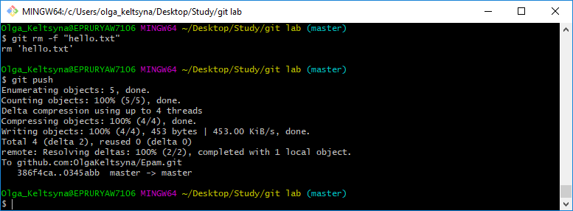

9.\* Add 2 additonal commits in "cherry-pick". Cherry-pick first commit to master. Revert the second commit. (2point)

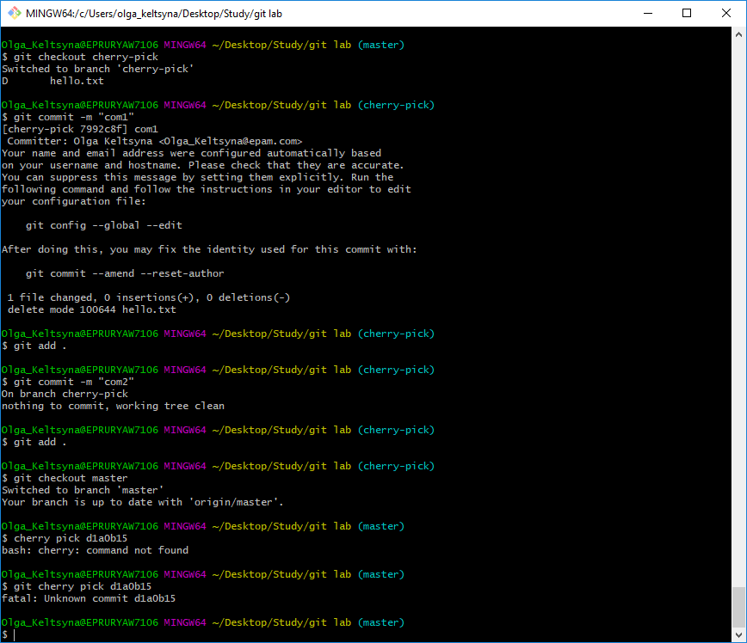

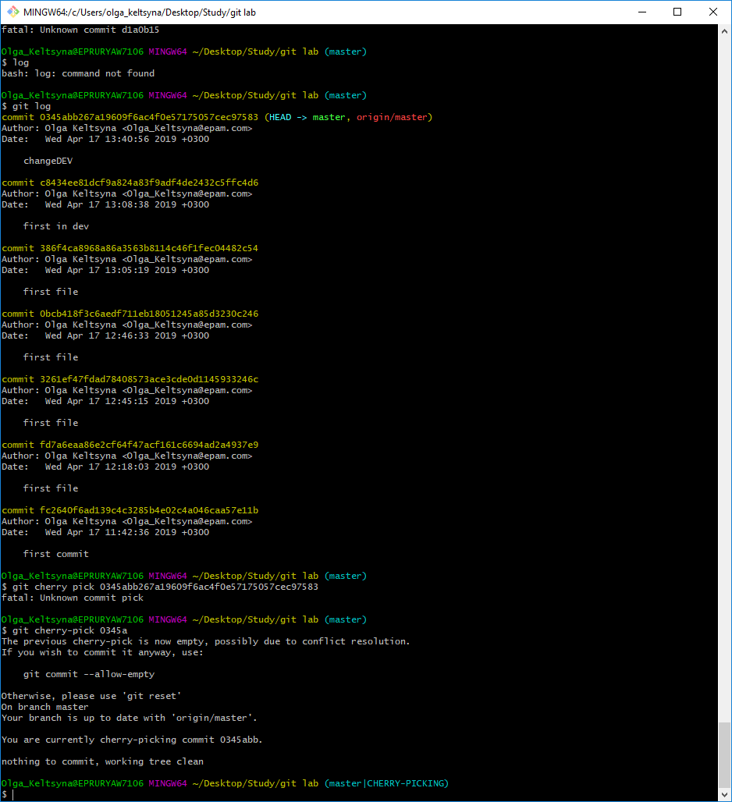

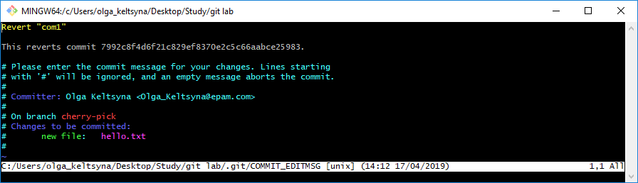

Исправлено:

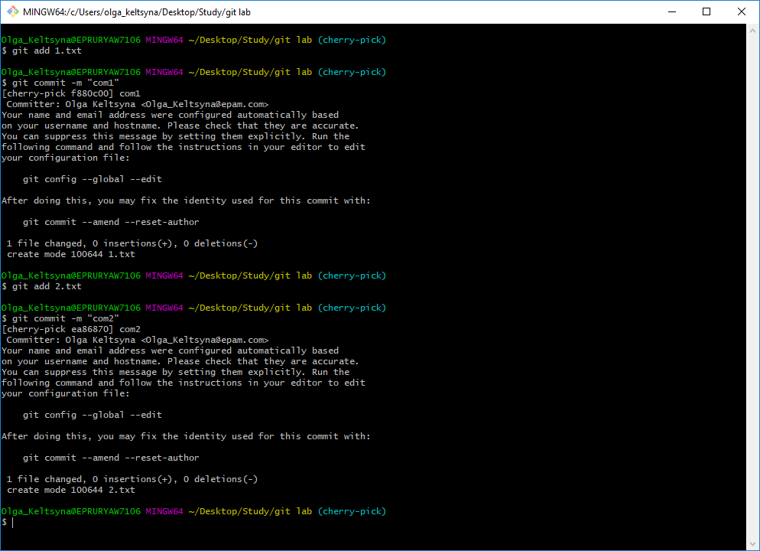

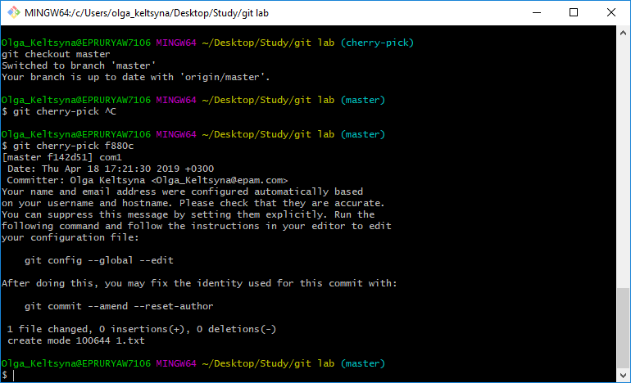

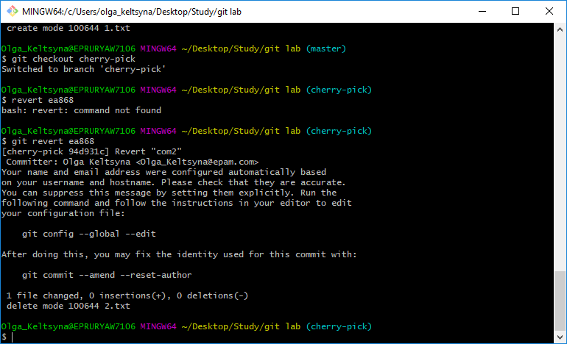

10.\* Change the color in the console and open the commit editing via Notepad. (1point)

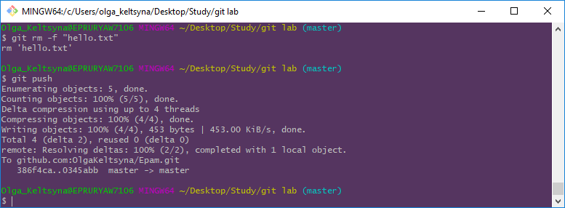

Не получилось скачать Notepad на компьютер. Дома делала команды:

git config --global core.egitor "(путь к программе)"

git commit -a